Project Title - Digital Twin of Multi-Motor System with Self-Healing Capability

Category E — Digital Twins / Electromechanical Systems

Real-World Application
This system models industrial multi-motor setups used in conveyor belts, robotics, and manufacturing lines, where fault detection and self-healing ensure continuous operation and prevent system failure.

System Description
The system consists of three different motors (DC, Servo, and Stepper) operating simultaneously. A digital twin model monitors their behavior, detects faults in one motor, and redistributes load to maintain overall system performance.

Inputs, Outputs, States, Parameters
This system models industrial multi-motor setups used in conveyor belts, robotics, and manufacturing lines, where fault detection and self-healing ensure continuous operation and prevent system failure.

Inputs  - Reference speed (ω_ref)  - Voltage input to motors  - Fault signal (disturbance) | Outputs  - Motor speeds (ω₁, ω₂, ω₃)  - Error signal (e = ω_ref − ω_actual)  - Fault detection signal
State Variables  - Angular velocity of each motor:  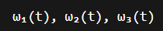 | System Parameters  - Motor constants (K)  - Resistance (R)  - Inductance (L)  - Inertia (J)  - Damping coefficient (B)  - PID gains (Kp, Ki, Kd)

Degrees of Freedom (DOF)
The system has: 3 Degrees of Freedom
The system has 3 degrees of freedom since each motor rotates independently and requires one state variable (angular velocity) to describe its motion. There is no mechanical coupling between the motors; hence each contributes one independent DOF.

Key Assumptions
- Motors are modelled as linear systems.
- Friction is viscous and proportional to velocity.
- Electrical dynamics are simplified into transfer functions.
- No mechanical coupling between motors (independent operation).
- Load sharing occurs only through control logic, not physical linkage.
- External disturbances affect only one motor at a time.
- System operates within stable region (no saturation effects).

Coordinate System & Sign Convention
- Positive rotation direction is assumed clockwise.
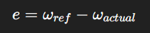
- Speed is measured in rad/s.
- Error is defined as:

Free Body Diagram
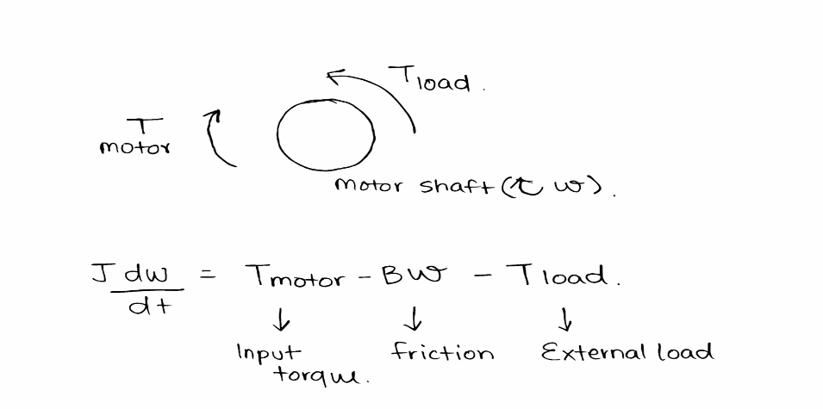

For each motor:  - Applied torque (T)  - Friction torque (Bω)  - Load torque  - Inertia (J)  - Change (dw/dt) | - Fault in motor = drop in Tmotor - T_{motor}Tmotor​  - Speed drops → ω decreases  - Error increases → digital twin detects fault  - Other motors increase torque → compensation

SYSTEM BEHAVIOR
- Under normal conditions, all motors track reference speed.
- When one motor experiences a fault (speed drop),
- The digital twin detects deviation using error threshold,
- Control system increases input to healthy motors,
- System maintains overall performance.

Why This System is Dynamic
This is a dynamic system because:
- Output depends on time-varying inputs
- System involves inertia and energy storage
- Behaviour changes under disturbance

